1ST GRADE ACTIVITIES
Week of March 30th-April 3rd
Below are some optional activities for at-home learning this week. All of the activities are a review of lessons taught previously this year. Happy learning!!!
SUBJECT |  | LEARNING ACTIVITIES
READING | Mini lesson 1: https://youtu.be/wcmS19PB0GQ  Mini lesson 2: https://youtu.be/ttdF1FbgL4A  Mini lesson 3: https://youtu.be/JMwrmzsiXOQ | Watch the short mini-lesson video and try the missions out in your own reading . Remember first grade readers read for 20-30 minutes each day.  -Readers can also review the snap words they already know.  -Readers can also be introduced to 4-5 new snap words a week.  -Day 1: Word detectives stop at the first sign of trouble and TRY SOMETHING.  -Day 2: Word detectives LOOK CLOSELY for clues. We look through the whole word from the beginning to the end.  -Day 3: Word detectives use EVERYTHING WE KNOW to solve a tricky word and to make sense of what is happening in our books.
WRITING | Writing Camp Day 1:  https://youtu.be/OnjUarviC1s  Writing Camp Day 2:  https://youtu.be/ZAmPSf5ZPOU  Writing Camp Day 3:  https://youtu.be/JMqR_H1aEnk | Watch the short mini-lesson video and try it in your own writing. Remember first grade writers write for 20-30 minutes each day.  -Day 1: I can make a writing plan with something I love.  Think of something you love. List small moments about it. Touch and tell or storytell one moment. Draw and write your small moment across the pages.  -Day 2: I can make a writing plan with strong feelings.  Think of a strong feeling. Think of a time you felt this strong feeling. List the moments. Touch and tell or storytell. Draw and write your small moment across the pages.  -Day 3: I can use texts or videos to create writing ideas.  Think about a song, poem, book, TV show, or video. Look at it through the eyes of a writer. What do you like about it? Try what you like about it in your own writing.
MATH | Day 1 | Number Sense  You have the following digits… 7, 5, 2, 4, 6, 3. What is the largest 2-digit number you can make? What is the smallest 2-digit number?  Equality (Source: https://www.openmiddle.com/)  Using the digits 1 to 9, at most one time each, fill in the boxes to create a true number sentence with the greatest possible value.  Counting  How many oranges are there? How did you count them? (Source: visualpatterns.org)
 | Day 2 | Word Problem  There were 3 apples on the table. Jan put 6 more apples on the table. How many apples were on the table in all? Show your work.  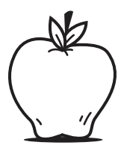  Guess My Number Game  Materials: None (Pencil and paper optional)  This is a great game you can play anywhere. One person thinks of a number between 1 and 10 (or 20, or higher), and the other players try to guess the number. After each guess, the person with the number says whether their number is greater or less than the guess. Guessers try to get the number in the fewest number of  guesses possible. (Source: mathforlove.org)  Interpreting Data  Make a graph that shows a possible result of 7 students’ favorite color with red being the most popular color. (Source: https://www.openmiddle.com/)  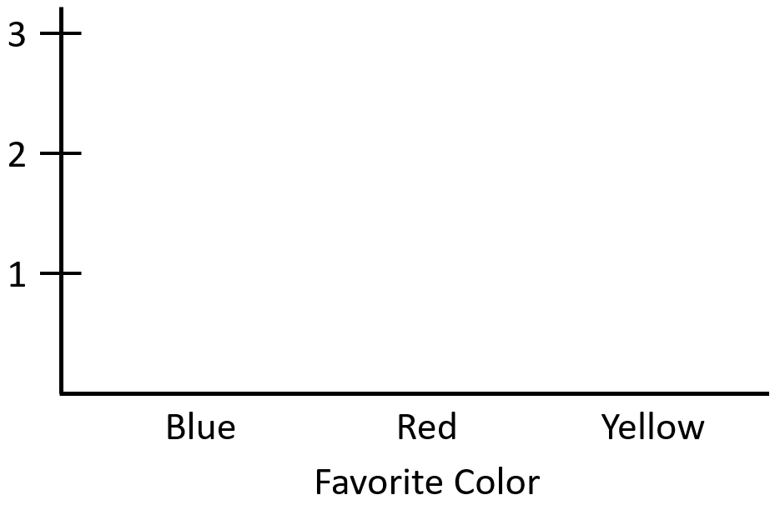
 | Day 3 | Drawing  Make a picture that is worth 14¢. You can use as many as you like of these shapes. Label your picture. Prove that it is worth 14¢. (Source: mathlearningcenter.org)  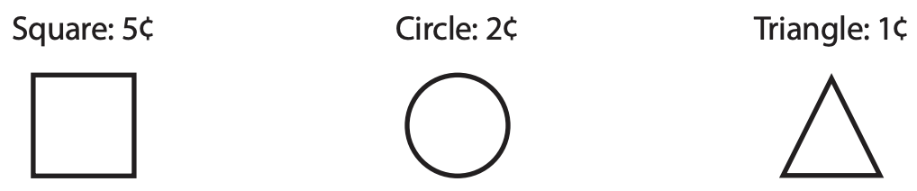  Which One Doesn’t Belong?  Choose one shape in this picture that you don’t think it belongs with the rest. Explain why. Can you pick another shape and give a different reason? (Source: wodb.ca)  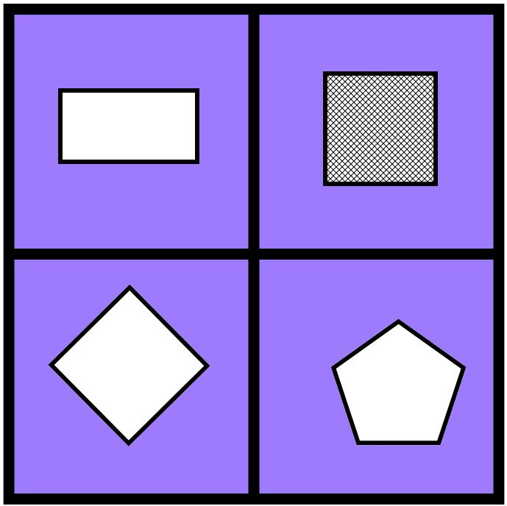  Noticing  On a piece of paper, make two columns. In one column, list the things that are the same in this picture, and in the other column, list the things that are different. (Source: https://samedifferentimages.wordpress.com/)  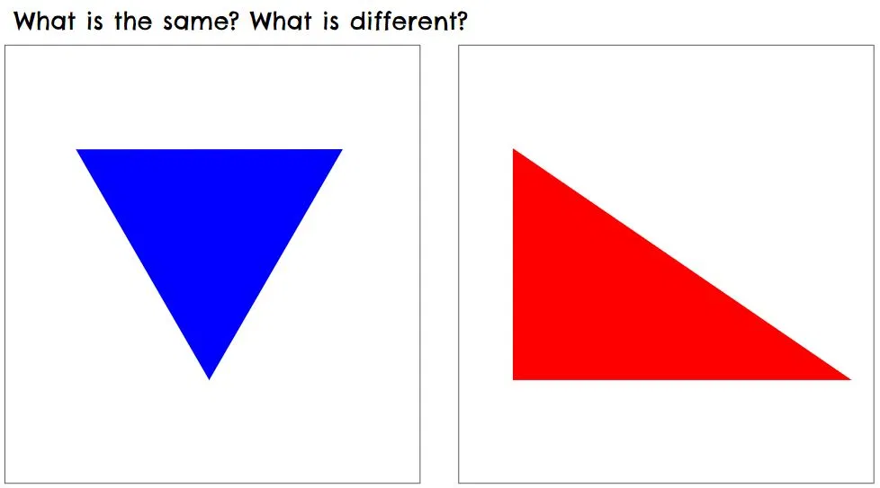
SCIENCE | 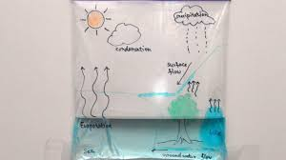 | Make your own water cycle and record your observations in your writing notebook everyday this week.  - Get a ziplock and draw a sun, tree, and cloud on the outside with a permanent marker.  - Mix ½ a cup of water with 2-3 drops of blue food coloring (or just use regular water).  - Pour the water into the ziplock bag and seal close.  - Tape the bag to a window that gets sun and observe what happens each day.  - You can record what you see happening in the water cycle with the permanent marker on the outside of the bag or draw your own diagram in your writing notebook and record what happens.
ART | https://www.youtube.com/watch?v=EZ2h6W4YVz0 | Follow along to learn how to draw a dinosaur with shapes. In this lesson you will learn how to add small shapes together to make bigger shapes.  Materials you will need:  -Paper  -Pencil  -Crayons/markers or colored pencils
MUSIC

PE

ADDITIONAL READING RESOURCES

