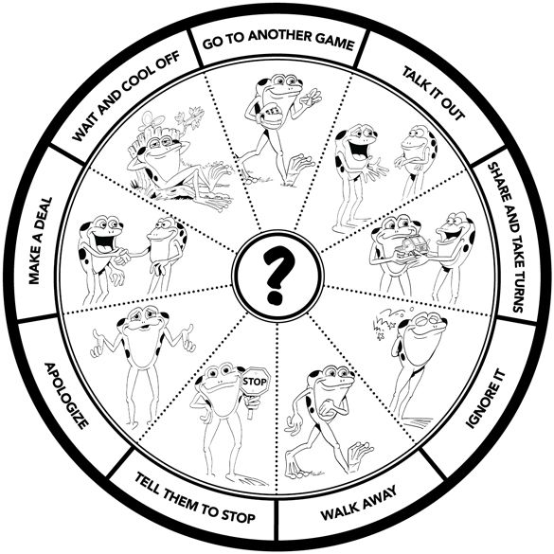

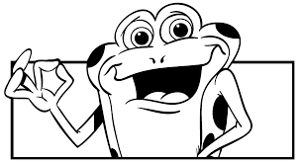
Problem Solving
Try 2 before talking
to a teacher or adult:
- Wait and cool off before attempting to solve the problem yourself
- Go to another game or activity
- Share and take turns
- Respectfully talk it over and listen to each other
- Ignore the problem or behavior
- Tell the person to stop the problem behavior
- Apologize “I’m sorry I…next time I will…”
- Make a deal or compromise “I can play with you as long as you…”
- Bugs and wishes “It bugs me when you… and I wish you would…”

